Chapter 2 – Descriptive Statistics

2.4 Measures of Variation

In exercise 1 – 3, use the grouped data formula to find the indicated mean and standard deviation.

- Pets per Household The results of a random sample of the number of pets per household in a region are shown in the histogram. Estimate the sample mean and the sample standard deviation of the data set.

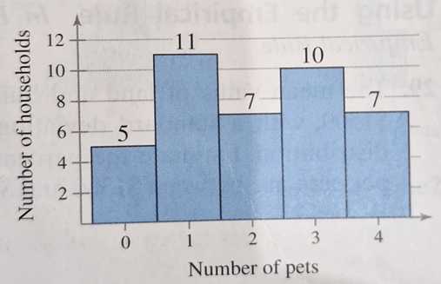

- Football Wins The number of gallons of water consumed per day by a small village are listed. Make a frequency distribution (using five classes) for the data set. Then approximate the population mean and the population standard deviation of the set data.

12 | 10 | 7 | 6 | 13 | 8 | 8 | 4 | 12 | 8 | 8 | 6
14 | 9 | 9 | 2 | 10 | 9 | 8 | 5 | 13 | 8 | 6 | 3
10 | 8 | 7 | 4 | 9 | 8 | 7 | 5

- U.S. Population The estimated distribution (in millions) of the U.S. population by age for the year 2011. is shown in the circle graph. Make a frequency distribution for the data. Then use the table to estimate the sample mean and the sample standard deviation of the data set. Use 70 as the midpoint for ’65 years and over.’

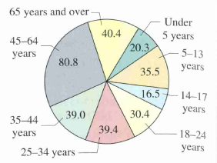

In exercise 4 – 5, find the coefficients of variation for each of the two data sets. Then compare the results.

- Annual Salaries Sample annual salaries (in thousands of dollars) for entry level software engineers in Raleigh, NC, and Wichita, KS, are listed.

Raleigh: | 69.5 | 74.2 | 65.1 | 56.5 | 65.6 | 62.1 | 79.5 | 72.4 | 58.3
Wichita: | 59.7 | 76.0 | 57.1 | 79.7 | 55.2 | 70.7 | 80.0 | 78.8 | 64.2

- SAT Scores Sample SAT scores for eight males and eight females are listed.

Male SAT scores: | 1010 | 1170 | 1410 | 920 | 1320 | 1100 | 690 | 1140
Female SAT scores: | 1190 | 1010 | 1000 | 1300 | 1470 | 1250 | 840 | 1060

- Fuel Consumption and Distances of Delivery Vehicles Sample fuel consumptions (in liters) and driving distances (in kilometers) for a fleet of delivery vehicles during a test run are listed.

Fuel (Liters): | 12 | 15 | 11 | 16 | 14 | 11 | 13 | 17 | 12 | 11 | 15 | 13
Distance (km): | 150 | 185 | 142 | 198 | 175 | 138 | 162 | 210 | 148 | 140 | 188 | 160

